| **SCHOOL OF SCIENCE AND HUMANITIES** | | | **DEPARTMENT OF BASIC SCIENCE** | |
| --- | --- | --- | --- | --- |
| **Program Name : B.Tech** | | **Assignment Type : LAB** | | **Academic Year: 2025-2026** |
| Name : | | Gandra Bala Aditya Reddy | | |
| Hall Ticket no: | | **2503A51226** | | |
| **Course Code** | **25SCI202BS106** | **Course Title** | **Computional Chemistry and Biology** | |
| **Year/Sem** | **1-1** | **Regulation** | **R25** | |
| **Date&Day of Assignment** | **06/08/2025** | **Time(s):** | **1-3 PM** | |
| **Duration** | **2 Hours** | **Applicable Batches** | **All Batches CSE** | |
| **Assignment Number : 01/12** | | | | |

**Molecular Visualization and Software Packages**

**Problem 1 :**

To study the structure of molecules and calculate the energy ,bond length &bond angle.

**Aim :**

To build a molecule and calculate the energyvalue, bond length &bondangle.

**Objective :**

1. Select a molecule structure.
2. Build the molecule in Avogadro.
3. Record the values **.**

**Procedure :**

1. Identify the target molecules and Build the model.
2. Validate geometry and optimization.
3. Retrieve and export the structure in standard molecular file formats(PDB).
4. Visualize and analyse the model using Avogadro.

**Result :**

* Molecules : water, ammonia, methane, benzene, phenol.

**1. Water(H2O)**

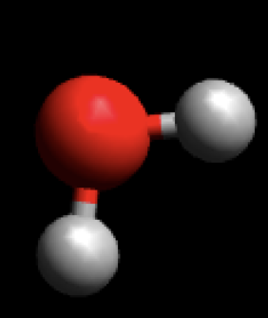

**Energy**1.17941e**-14** KJ/mol

**Bond length Bond angle =**38.00

O-H=0.969A0

H-H=1.527A0

**2. Ammonia(NH3)**

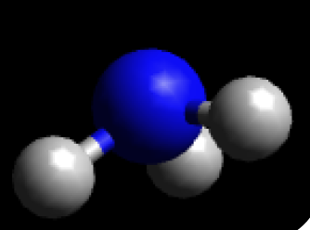

**Energy**1.37113e**-14** KJ/mol

**Bond length Bond angle =** 30.00

H-N=1.005A0

H-H=1.741A0

**3. Methane(CH4)**

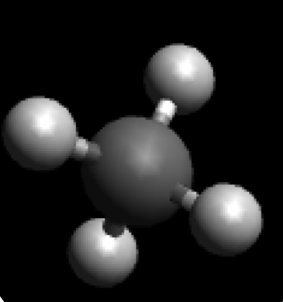

**Energy**0.110457 KJ/mol

**Bond length Bond angle =**35.30

H-H=1.784A0

C-H =1.092A0

**4. Benzene(C6H6)**

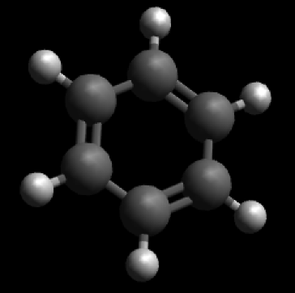

**Energy**67.9391 KJ/mol

**Bond length**

C-C =1.395A0

C-H =1.087A0

C=C =1.395A0

**Bond angle**

C-C-H =1200

C=C-C =300

**5. Salicyclic acid (C7H6O3)**

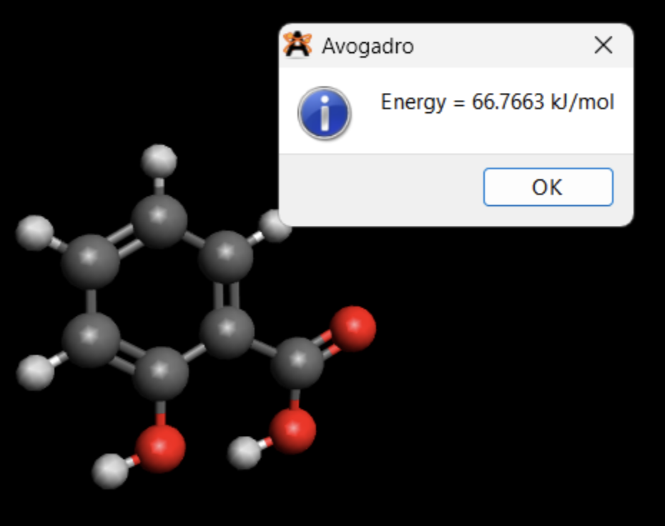

**Energy**66.7663 KJ/mol

**Bondlength Bondangle**

C-C =1.395A0 H-O-C =108.40

C-H =1.086A0  C-C=O =122.50

C=C =1.397A0 C-C-C =124.00

C-O =1.372A0 C=C-H =120.00

O-H =0.976A0 C-C-H =26.20

C=O =1.221A0

**6. Doxorubicine (C27H29NO11 . HCl)**

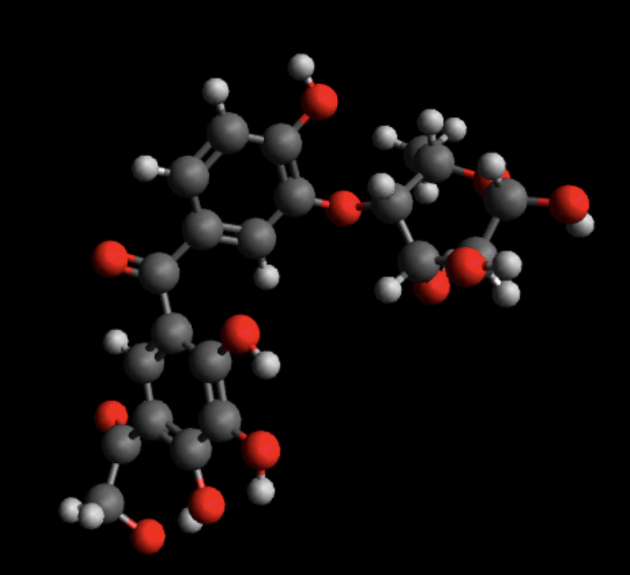

**Solution to problem :**

We can successfully build structure of molecule(s). We can check the energy of molecule , bond length & bond angle.

**Outcome :**

Wecan generated the model of molecules like water,ammonia,methane benzene,salicyclic and we analyse it calculate the energy of molecule ,bond length, bond angle.